 |  | Alain Massé  Directeur général  ا المدير العام  Director general
  Union Radiophonique et Télévisuelle Internationale
  الاتحاد الإذاعي والتليفزيوني الدولي
  International Radio and Television Union

Object: Request for programmes for the 2012 exchange catalogue

Paris, June 15 2011

Dear colleagues,

URTI increases (25 new public broadcasters in the last two years) in order to always better meet its members’s needs, by improving its exchange platform which already proposes more than 3,000 programmes free of rights. These exchanges allow you to save important amounts of money by ordering for free quality programmes of which the rights were freed by other members. They also ensure the international broadcast of programmes of which you can yourselves free the rights.

Since the beginning of this year, URTI launched a new particularly innovative Web site (http://www.urti.org) to help you to better choose the programmes of its exchange catalogue by viewing extracts.

We ask you to send us your programme offers as soon as possible, which must be free of rights for our Union members and in accordance with one of these three genres: documentaries, children’s programmes and culture (interviews, portraits).

We thank you in advance to send us your programmes free of rights with the registration form here enclosed as soon as possible. We also ask you to plan your presence in the next Television Commission which will meet in Albania from Thursday November 17 until Tuesday 22 2011 at the kind invitation of RTSH, to participate in the selection of the new programmes which will be chosen for the URTI 2012 catalogue.

We also draw your attention on the need to provide, as far as possible, programmes without logo and with their scripts to make their adaptation in several languages easier.

Knowing we can count on your contribution to our programme exchanges, we also stay at your disposal to deal with your next programme orders which propose contents adapted to the needs of your channels. Fabienne Rémond is ready to guide you on this path (fremond@urti.org).

We are looking forward to your answer soon.

Kind regards,
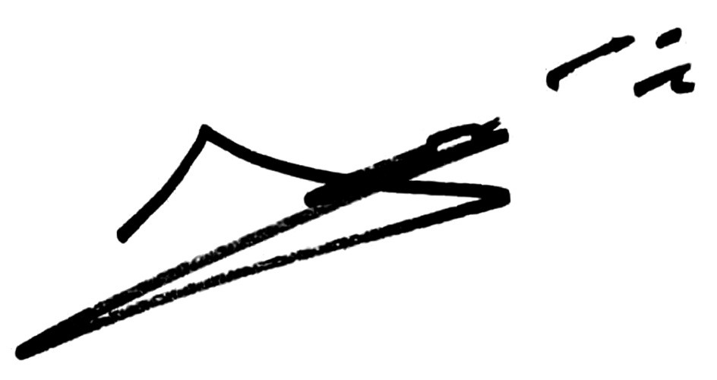

Maison de Radio France - 116, avenue du Président Kennedy - 75220 - Paris Cedex 16 - France
 : +33 1 56 40 16 04 / +33 1 56 40 20 62 / +33 1 56 40 17 81 -  : +33 1 56 40 17 82 -  : urti@urti.org
http://www.urti.org

